

**Symantec Backup Exec (Versions prior to BEX 2012)**

**Plugin Configuration Guide**

Contents

Backup Exec Legacy Configuration Checklist 2

Supported Collection Types 2

Data Sources 2

Requirements 2

Backup Exec Log File Location 2

Setup 3

Server Properties 3

Field Definitions 3

Technical Support 5

# Backup Exec Legacy Configuration Checklist

While detailed steps are included below, this is an overview of the steps to configure Backup Exec collections on your Bocada Data Collection Server:

* Verify that you have BEX 2010x or earlier. Later versions should use the regular Bocada Backup Exec plugin.
* Verify location of the Backup Exec log files, and user credentials with access to that location.
* Verify required TCP port has been opened.
* Add the Backup Exec server to Bocada under Operations > Backup Servers, and set Server Properties.

# Supported Collection Types

The plugin currently supports the following collection types from Backup Exec 2010 servers:

|  |  |  |
| --- | --- | --- |
| **Collection Type** | **Supported** | **Description** |
| Backup | ✓ | Collects transactional details about backup, duplication and restore jobs. Example metrics include, start times, durations, bytes, files, errors etc. |
| Storage |  | Collects point-in-time inventory information. Example metrics include, total recoverable gigabytes (storage), media volume count, media volume status, etc. |
| Policy |  | Collects and stores information on policy attributes, schedules, storage units, storage groups, storage lifecycle policies and clients. |

# Data Sources

This plugin relies on the following Backup Exec data source:

* Backup Exec log files
* SQL Database (optional)

# Requirements

Backup Exec Log File Location  
The plugin needs the location of the log files on the Backup Exec server in order to collect data. The preferred method is to provide the plugin with the path to the log files. A login with read access to the Backup Exec log files is required. Alternatively, the plugin can determine the Backup Exec log file location by reading the Windows Registry. *In order to read the Windows Registry the plug- in requires Administrator access. This level of access is not required if the plugin is provided the path to the log files.*

The Bocada Data Collection Server must be able to connect to the Backup Exec server on the port(s) that the Backup Exec software responds to. By default, the TCP port for a Backup Exec server is 445 for SMB (files) and 1433 for MSSQL (optional).

# Setup

### Server Properties

Backup Server Properties determine how the plugin will interface with the Backup Exec server and are managed through the Backup Servers view.

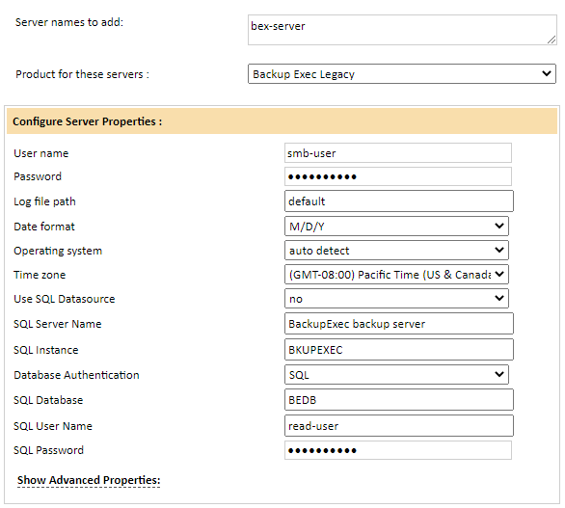

### Field Definitions

#### User Name & Password

Enter a user name and password the plugin will use to access the Backup Exec .xml log files of the backup server. This should be in the form of [Domain] \ [username]

#### Log File Path

Provide the path to the directory containing the Backup Exec log files. Enter a path, choose default, or leave this setting blank.

* Entering a path directs the plugin to look in the specified location, requiring only read access to the location of the log files.
* Choosing default directs the plugin to search the Backup Exec server for the log file location and requires Administrator level access (the plug-in will attempt to locate the log file path by reading the registry). Backup Exec will place these in C:\Program Files\Veritas\Backup Exec\log by default.
* To determine an unknown log file path:
  1. Log on to the Backup Exec server
  2. Open Start > Run > regedit
  3. Browse to HKEY_LOCAL_MACHINE > SOFTWARE > VERITAS > Backup Exec > User Interface > Data Path Remote (this is the location of the log files)
* Note: Do not include the server name in the Log File Path, as it is automatically added by the plugin.

#### Date Format

Select the date format used by the Backup Exec log files. Defaults to ‘Not specified’, but must be set to one of the following:

* M/D/Y
* D/M/Y
* Y/M/D

#### Operating System

Leave this as “auto detect” or select Windows if that is unsuccessful. Support for NetWare has been deprecated and this field will be removed in a future release.

#### Time Zone

Select the time zone where Backup Exec server resides. This setting ensures times are displayed consistently in environments that span multiple time zones. Defaults to the default time zone of your Bocada Installation (see ‘Settings’, in the *Bocada Administration Guide*).

#### Use SQL Datasource

Defaults to ‘no’. This may be set to ‘yes’ when testing the connectivity to the Backup Exec SQL database.

#### SQL Server Credentials

Enter the properties to access the Backup Exec SQL Server:

* SQL Server Name (defaults to the name of the Backup Exec server)
* Instance, if applicable (defaults to ‘BKUPEXEC’)
* Database Name (default is ‘BEDB’)
* Database Authentication method (default is SQL Authentication)
* SQL Username and password with access to the database

# Technical Support

For technical support or a copy of our standard support agreement, please contact us.

**E-mail:** [support@bocada.com](mailto:support@bocada.com)

**Support Portal:** <https://bocada-support.force.com>

**Phone:** +1-425-898-2400